DA505 FINAL - FALL 2021 - SOLUTION

Name:

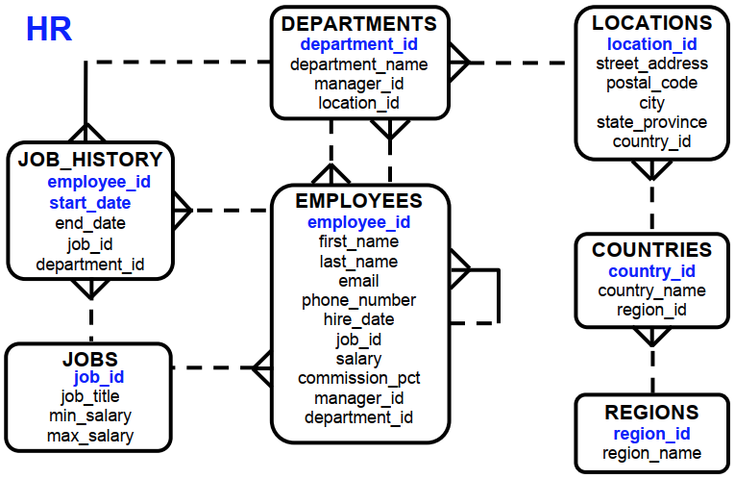

Q1. (15 Pts)

The HR department needs a query to display the jobs (job_id) that are found in the Administration and Executive departments. Also display the number of employees for these jobs. List highest number of employees first.

SELECT e.job_id, COUNT(e.job_id) cnt
FROM hr.employees e JOIN hr.departments d
ON e.department_id=d.department_id
WHERE d.department_name IN ('Administration','Executive ')
GROUP BY e.job_id
ORDER BY cnt DESC;

Q2. (15 Pts)

Write a query to the display the job, the salary for that job based on the department id, and the total salary for that job, for departments 20, 50, 80 and 90.

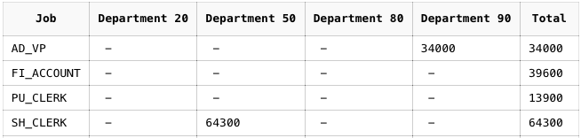

SELECT job_id "Job",
SUM(DECODE(department_id, 20, salary)) "Department 20",
SUM(DECODE(department_id, 50, salary)) "Department 50",
SUM(DECODE(department_id, 80, salary)) "Department 80",
SUM(DECODE(department_id, 90, salary)) "Department 90",
SUM(salary) "Total"
FROM hr.employees
GROUP BY job_id;

Q3. (15 Pts)

Write a query to display the employee’s first name, last name, department name, country name and region name who works in ‘Americas’ and not working in Shipping department.

SELECT e.first_name, e.last_name, d.department_name, c.country_name, r.region_name
FROM hr.employees e
JOIN hr.departments d ON d.department_id=e.department_id
JOIN hr.locations l ON l.location_id=d.location_id
JOIN hr.countries c ON c.country_id=l.country_id
JOIN hr.regions r ON r.region_id=c.region_id
WHERE r.region_name='Americas' AND d.department_name<>'Shipping';

Q4. (15 Pts)

Find all employees (first_name, last_name, hire_date) who were hired in the first half ot the month (before the 16th of the month). Sort the results by employees’ last name.
Hint: Use only Employees table

SELECT first_name, last_name, hire_date
FROM hr.employees
WHERE TO_CHAR(hire_date, 'DD') < 16
ORDER BY last_name;

Q5. (15 Pts)

What is the question for this query?

SELECT last_name, TO_CHAR(hire_date, 'DAY') day
FROM employees
WHERE TO_CHAR(hire_date, 'DAY') IN (SELECT TO_CHAR(hire_date, 'DAY')
FROM employees
GROUP BY TO_CHAR(hire_date, 'DAY')
HAVING COUNT(*) = (SELECT MAX(COUNT(*))
FROM employees
GROUP BY TO_CHAR(hire_date, 'DAY')));

List all employees who were hired on the day of the week on which the highest number of employees were hired.

Q6. (15 Pts)

Write a query to display the departments where no sales representatives work. Include the department number (department_id), department name and location (location_id) in the output.

SELECT department_id, department_name, location_id
FROM hr.departments
WHERE department_id NOT IN (SELECT department_id
FROM hr.employees
WHERE job_id='SA_REP' AND
department_id IS NOT NULL);

Q7. (10 Pts)

HR department needs a query to display department no (department_id), department name and the number of employees working in each department which has fewer than three employees.

SELECT d.department_id, d.department_name, COUNT(*)
FROM hr.departments d JOIN hr.employees e
ON d.department_id=e.department_id
GROUP BY d.department_id, d.department_name
HAVING COUNT(*) < 3;

Q8. (10 Pts)

StudentID
StudentName
CampusAddress
Major
CourseID
CourseTitle
InstructorName
InstructorRoom
Grade

Functional Dependencies:
StudentID StudentName, CampusAddress, Major, Grade
CourseID CourseTitle, InstructorName
InstructorName InstructorRoom

Please normalize the above scheme through 1st, 2nd and 3rd normal forms.
Any answer, other than the solution might be accepted, provided that your design is consistent within itself.

Your answer must to be in following format;

1NF: (2pts)

RELATION_NAME(A,B,C)
RELATION_NAME(D,E,F)

Why 1NF? Which attributes did you choose for PK in each relation?

2NF: (2pts)

RELATION_NAME(A,B,C)
RELATION_NAME(D,E,F)

Why 2NF? Which attributes did you choose for PK in each relation?

3NF: (6pts)

RELATION_NAME(A,B,C)
RELATION_NAME(D,E,F)

Why 3NF? Which attributes did you choose for PK in each relation?

Add a new FD:
InstructorID InstructorName, InstructorRoom

1NF:

STUDENT (StudentID, CourseID, StudentName, CampusAddress, Major, CourseTitle, InstructorName, InstructorRoom, Grade)

2NF:

STUDENT (StudentID, StudentName, CampusAddress, Major)

STUDENT_COURSE (StudentID, CourseID, Grade)

COURSE (CourseID, CourseTitle, InstructorName, InstructorRoom)

3NF:

STUDENT (StudentID, StudentName, CampusAddress, Major)

STUDENT_COURSE (StudentID, CourseID, Grade)

COURSE (CourseID, CourseTitle, InstructorID)

INSTRUCTOR (InstructorID, InstructorName, InstructorRoom)

